MATCH REPORT: -
JUNIOR A FOOTBALL CHAMPIONSHIP Round 1 2016
BALLYVAUGHAN FANORE 3:10 Doonbeg 0:05
VENUE: - Gurteen
DATE: - 17-08-2016
MATCH OFFICIAL: - Kieran Harvey (Ennistymon)

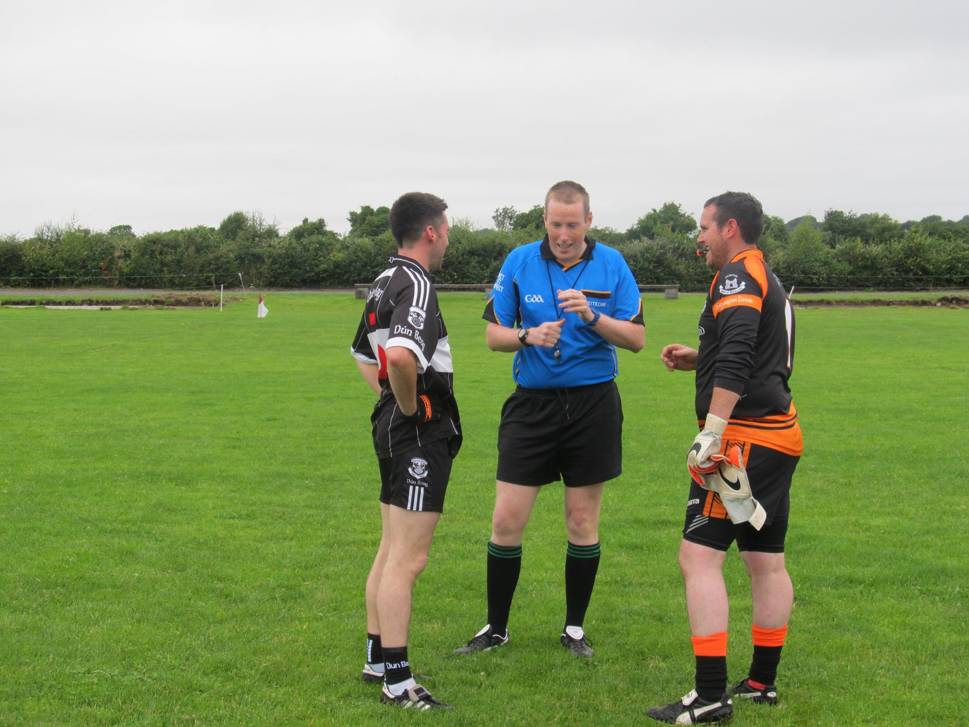

After a disastrous Division 4 Football League campaign Ballyvaughan-Fanore's championship's aspirations came to life with the demolition of Doonbeg at Gurteen, the home of St Joseph's Doora Barefield on the 17th July. The league had finished on a low as relegatation to division 5 for 2017.
Ballyvaughan-Fanore’s greater attacking prowess and craft in attack eventually wore down a determined Doonbeg challenge. It was oblivious that the goals that were scored in the first half would be key to the victory.
Jonah Culligan was making a championship debut and Neil Walsh was also back on the championship team excelled throughout this game as they scored (2:03) and (1:04) respectively between them. Neil rowed in with a haul of (1:04) in the first half which was totally dominated by Ballyvaughan-Fanore, Jonah Scored (1:00) in the first half and he was totally scorer and chief in the second half with 1:03 all from play , Adrian Nilan (0:02) and Raymond Casey (0:01) were Ballyvaughan-Fanore's other scorers with points from play. A totally dominant performance in the first half left the score standing at Ballyvaughan-Fanore 2:07 Doonbeg 0:01.This only score that Doonbeg got was scored from play around midway through the first half.

A short time after the second half had restarted Ballyvaughan-Fanore were dealt a blow when referee Kieran Harvey from Ennistymon gave Raymond Casey his marching orders to the sideline as he was dismissed on a second yellow card.
A defensive game came in to plan action as we were now playing in to the wind for this half, it was going to be tough as proved in the first half, as Doonbeg kicked 5 wides to 2 for us and lost heaps of possessions going forward. The score line tells its own story but it could have been worse but Doonbeg giving it their all in the second thirty minutes of play.

Jonah Culligan was influential all through the game and as a newcomer to the side he led the challenge and made sure Ballyvaughan-Fanore led from start to finish.
Doonbeg cause was not helped dropping balls short in to Damien McNamara’s hands and their wides tally also hit double figures early in the second half.
Ballyvaughan-Fanore : -
Damien McNamara, (Captain)
Sean McNamara, Diarmuid Greene and Adam Walsh,
James Howard, Kieran Casey and Mark Walsh
James Hynes and Jonah Culligan
Pat Hayes, Raymond Casey and Adrian Nilan
Ronan Fahy, Neil Walsh and Joe O’Loughlin
Subs: -
Philip Queally for Mark Walsh (35, injured)
John Linnane for Joe O’Loughlin (50)
Gary Crowe for Neil Walsh (55)
Scorers: - Jonah Culligan (2:03), Neil Walsh (1:04), Adrian Nilan (0:02) and Raymond Casey (0:01).

