Junior Football Division 4 League Round 3:
Ballyvaughan 1:07 Michael Cusack’s 2:07
Venue: - Ballyvaughan Community Field
Date: 19-04-2015
Referee: - Pat O’Connell

Crucial goals the difference as Michael Cusack’s overcome Ballyvaughan on home turf.

The large crowd in attendance was treated to a most entertaining encounter
This game was entertaining with both teams enjoying periods of dominance and there were many fine displays from the players on the field, with a bit of bite also to it.

Ballyvaughan suffered defeat at the hands of the old rivals Michael Cusack's in the third round of the Junior A Football League played on Sunday 19th at the Community Field. Michael Cusack's advance to the next round of the competition and gathered up the two valuable points on offer with a narrow three point victory in this tense hard fought Burren derby. Michael Cusack's proved to be the better side than Ballyvaughan but had to fight until the end to ensure their victory, as a goal at the right time did swing the tie back in favor of Michael Cusack's this was fisted to the net from play by Sean Brosnan after a sloppy passage of play saw Ballyvaughan get turned over in possession and conceded this goal rather easily.

With the exception of that exciting finish, this wasn’t a great game of football, spoiled somewhat by far too many unnecessary fouls .

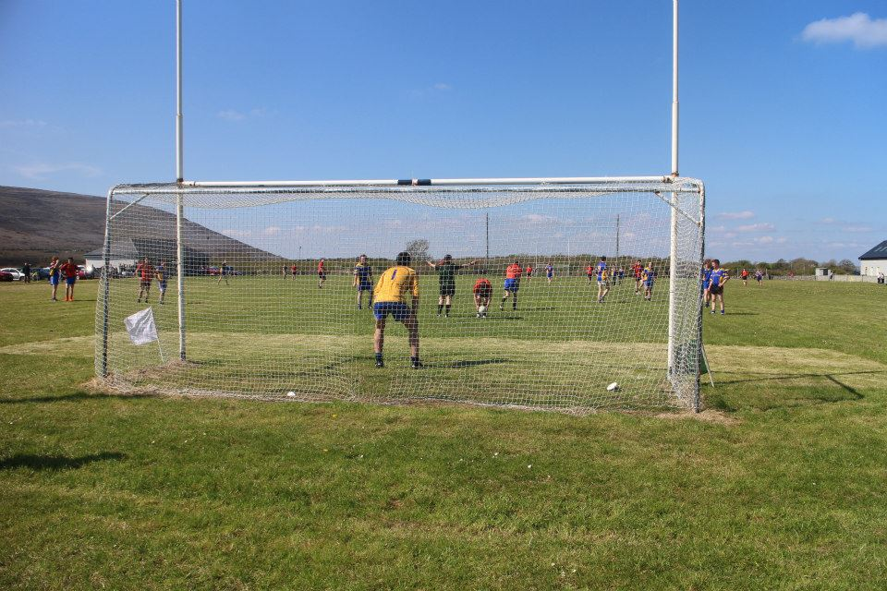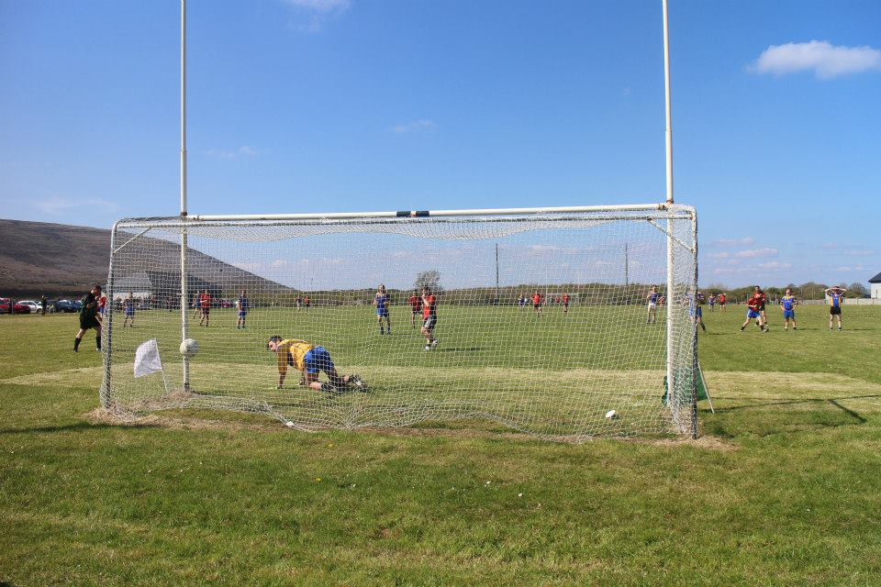
Ronan Fahy shoots to score a point from play, picture one captured by Willy O’Reilly, picture two sees Ronan watch the ball sail over the bar which was caught on camera by Conor Mahon 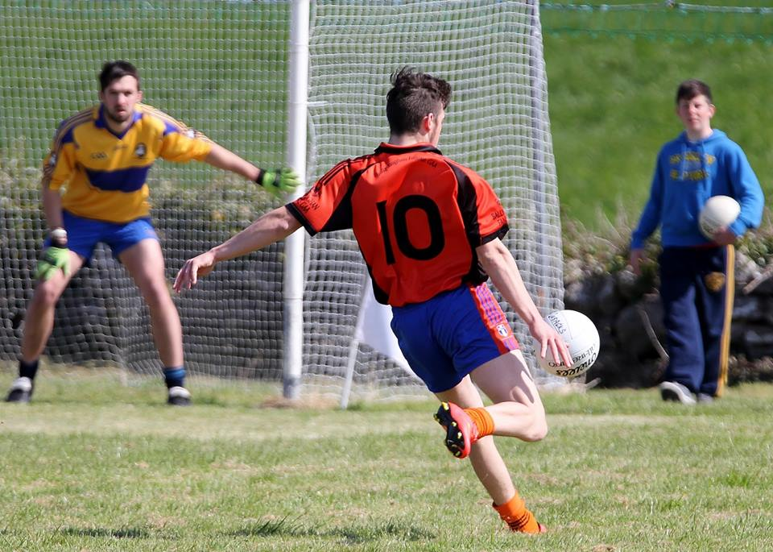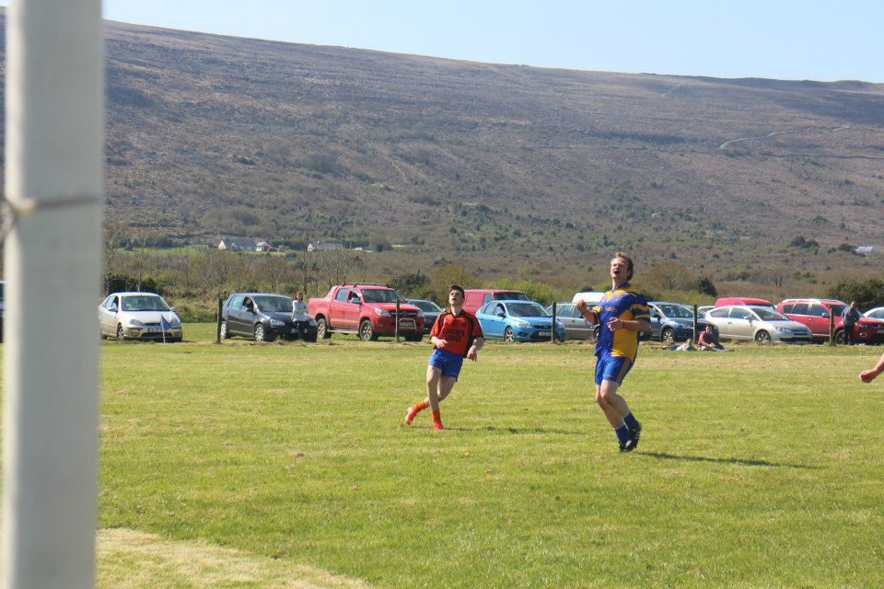

Ballyvaughan: - Team and Scores
Damien McNamara.
Mark Walsh, Kieran Casey, Mark O’Loughlin.
Adam Walsh, Sean McNamara, James Howard.
James Hynes (0:03, 3 Play) & Kevin Carrucan (0:01, 1 Play)
Ronan Fahy, (0:01, 1 Play) Pat Hayes, Philip Queally
William McGann, Gary Crowe, Adrian Nilan. (1:02, 1:00 Penalty, 2F)
Subs: -
Martin Howard for Gary Crowe (22 Mins)
Phelim Kyne for Pat Hayes (50 Mins)

Michael Cusack’s: - Team and Scores
Ruaidri McMahon
Robert Hunt, Seamus O’Conghaile, Killian Droney.
Michael O’Connor, (0:01, 1 Play) Colm Davern Robbie Cassidy (1:00)
John Fawl & Kevin Fawl.
Cathal Murray, Hugh Kelly, (0:01, 1 Play) Sean Naughton.
James Droney, Aidan Forde, (0:03, 3 Frees) Tadgh Geoghegan.

Subs: -
Sean Brosnan (1:02, Play) for Cathal Murray (Black Card)
Tomas Fahy.

Conor Mahon’s Pictures can be view on Facebook at the link below.
https://www.facebook.com/media/set/?set=a.900857713270973.1073741829.113263228697096&type=1

Willy O’Reilly Facebook Pictures can be view on Facebook at the link below.
https://www.facebook.com/media/set/?set=a.809073242480330.1073742049.385332904854368&type=1
Previous Results and Fixtures Between Michael Cusack’s and Ballyvaughan.
Below documented are the most recent league and championship meetings between Ballyvaughan and Michael Cusack’s since 2000, various competitions and grades have been contested by both teams including an Intermediate Football Final, Intermediate Football Championship, Cusack Cup Division 2b senior football league, Senior League John O’Gorman Cup, Banner Cup Division 3 Intermediate Football League, Junior A Football Championship, Geraldine League Division 4 Junior Football League, and also Junior B Football League semi-final and U21C Football Championship twice which included one final in 2001.

Intermediate Football Championship 2013
04-08-2013 | Gleann Chisog | Ballyvaughan | 3:07 | V | 1:08 | Michael Cusack's

Geraldine League Division 4 Football League
07-04-2012 @ 14:00 | Ballyvaughan | Ballyvaughan | 0:07 | V | 3:11 | Michael Cusack’s
Junior A Football Championship
22-09-2012 | Ennistymon | Ballyvaughan | 0:03 | V | 0:07 | Michael Cusack's
Banner Cup Division 3
22-04-2011 @ 20:00 | Gleann Chiosog | Ballyvaughan | 0:06 | V | 0:07 | Michael Cusack's

19-06-2010 | Gleann Chiosog | Ballyvaughan | 0:10 | V | 0:07 | Michael Cusack’s

Banner Cup Division 3
01-03-09 @ 13:00 | Gleann Chiosog | Ballyvaughan | 1.12 | V | 1.07 | Michael Cusack's

Senior League John O’Gorman Cup
26-03-08 | Gleann Chiosog | Ballyvaughan | 0.11 | V | 1.06 | Michael Cusack's

Banner Cup Division 3
08-03-08 | Ballyvaughan | Ballyvaughan | 0.06 | V | 1.03 | Michael Cusack's

Intermediate Football Final 2007
30-09-07 Final | Cusack Park  Ennis | Ballyvaughan | 0.10 | V | 0.08 | Michael Cusack's

Intermediate Football Championship 2006
27-05-06 | Ennistymon | Ballyvaughan | 0.08 | V | 0.09 | Michael Cusack's

Banner Cup Division 3
25-04-04 | Gleann Chiosog | Ballyvaughan | 2.07 | V | 2.10 | Michael Cusack's
06-04-02 | Ballyvaughan | Ballyvaughan | 0.09 | V | 2.00 | Michael Cusack's
19-10-02 Play Off | Corofin | Ballyvaughan | 0.08 | V | 0.11 | Michael Cusack's

Cusack Cup Division 2B
01-07-01 | Gleann Chiosog | Ballyvaughan | 2.07 | V | 0.10 | Michael Cusack's
29-07-00 | Ballyvaughan | Ballyvaughan | 0.16 | V | 2.10 | Michael Cusack's

