Junior Football Division 4 League Round 2:
14-05-2013 @14:00
Lissycasey 3-2 Ballyvaughan 1-5:
Referee: - Pat Cosgrove (Corofin)
Venue: - Ballyvaughan Community Field

With a level one Tornado forecasted for Ireland this fixture was always going to be a tough enough encounter and as promised it did not disappoint. When Lissycasey overcame Ballyvaughan by 3:02 to 1:05 in round 2 of this Geraldine League Division 4 football game played at Ballyvaughan Community Field on Sunday.

http://www.breakingnews.ie/ireland/ireland-under-tornado-warning-591284.html can be checked for the people that want to find out more about the Tornado, but I will try to describe this Tornado effect at Ballyvaughan Community Field as best I can.
Lissycasey had their first outing in the division 4 league when they made the long journey to Ballyvaughan on Sunday and recorded a three point win over the home side. A strong wind made conditions difficult for the teams and the visitors had the aid of the elements in the opening half.

Two goals from Eoghan O'Leary and one from Killian McNamara gave the visitors the upper-hand and they led at the break after amassing their total score in the opening period, the points coming from O'Leary and Oisin Talty. Solid defence in the second half ensured that they held the advantage to the end.

Ballyvaughan were only able to score one point in the first half and Lissycasey were kept scoreless in the second half as all the damage was done in the first for Lissycasey and they held out for a one point victory.

Lissycasey: Killian Normoyle; Seamus Collins, Michael Nagle, Kevin Moran; Cyril Sheehan, Derek McMahon, Dan Meaney; Brendan O'Connor, Noel Finnucane; Oisin Talty, Danny Lynch, Killian McNamara; Eoghan O'Leary, Paudie Carmody, David McMahon: Sub: Kieran Clancy.

Ballyvaughan:-
James Callinan; John Linnane; Sean McNamara; Tomas Francis; Mark O’Loughlin;
Kieran Casey; Mark Walsh; James Hynes; Damien Martyn; Philip Queally; Kevin Carrucan; Phelim Kyne; Steve Hynes; Cillian Mahon; Damien McNamara.
Subs: - Cillian Fahy for Cillian Mahon.

Ballyvaughan: - Philip Queally (1:00); Damien McNamara (0:02); Stevie Hynes (0:01); Kevin Carrucan (0:01); Damien Martyn (0:01).

Lissycasey: - Eoghan O’Leary (2:01); Killian McNamara (1:00); Oisin Talty (0:01)

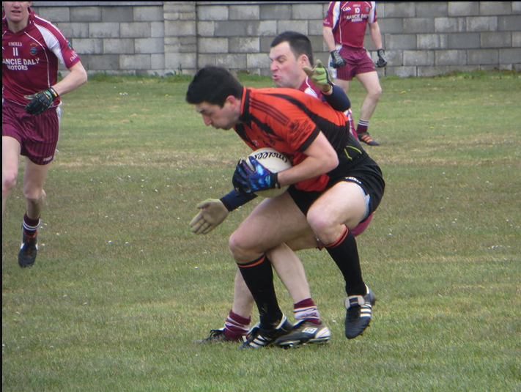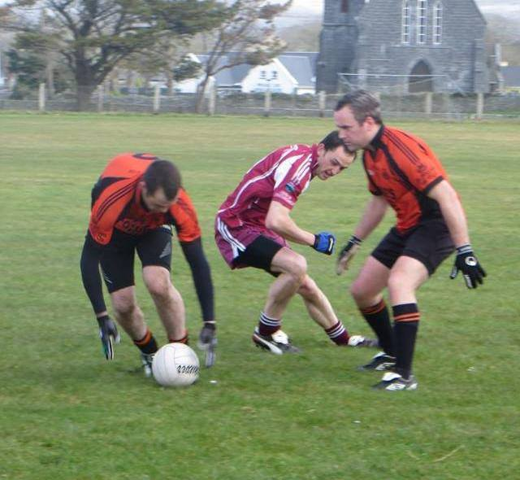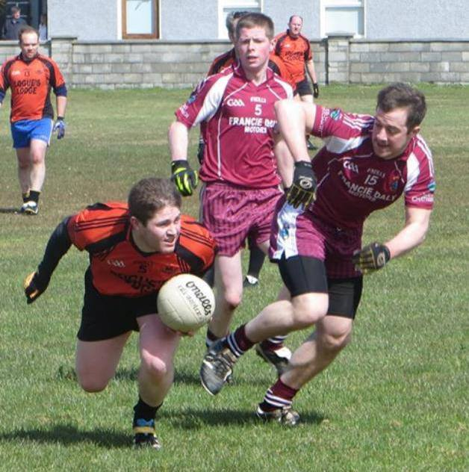

Pictures Supplied by Conor Mahon

